Kanban Guidelines
ITS-GL014, Ver 1.1


Sharda Centre, Off Karve Road, Erandwane,
Pune, Maharashtra, India 411004

www.techmahindra.com

Table of Contents
1. PURPOSE 2
2. SCOPE 3
3. Definitions & Acronymns 3
3.1 Other Reference 3
3.2 Definitions 3
3.3 Acronyms 3
4. SUITABILITY 3
4.1 Introduction 3
4.2 Key Benefits of using Kanban 3
5. METHODOLOGY OVERVIEW 4
5.1 Visualize Workflow 4
5.2 Limit Work In Process (WIP) 4
5.3 Measure the lead TIME AND Improve Flow 4
6. PHASE DESCRIPTIONS 4
6.1 Steps to Implement Kanban 4
6.1.1 Define a work process flow 4
6.1.2 Lay Out a Visual Kanban Board 5
6.1.3 Place prioritized goals on the left column of the board 6
6.1.4 Decide on limits for items in queue and work in progress 6
6.1.5 Start the board by placing stories or features in queue 6
6.1.6 Move features through the process flow as work is completed 6
6.1.7 Use the dates on the cards to calculate cycle time 6
6.1.8 Display and manage cycle times 6
6.2 Additional kanban usage guidelines 6
6.2.1 Explode large process steps into tasks to improve visibility of flow 6
6.2.2 Use cumulative flow diagrams to visualize work in progress 7
6.2.3 Keep regular time-boxes in your process as a cue for product inspection 7
6.2.4 Evaluate your pace of development: 7
6.2.5 Evaluate and adjust the process you’re using 7
7. DOCUMENT HISTORY 7
8. ANNEXURE 8

PURPOSE
The objective of this document is to provide a common guideline for Kanban Best Practices, which Agile Software development projects can benefit from Adopting.
This document provides how Kanban best Practices can be adopted by current Agile Software Development/ Enhancement / Testing Projects.
Kanban best Practices described below are recommended as ‘Complimentary’ Best Practices to the existing Agile Framework covered in Agile Tool Kit.

SCOPE
The guideline provides general understanding and points to be taken care for effective implementation of Kanban Best Practice.

Definitions & Acronymns

Other Reference
- Anderson, Kanban in Action: http://www.agilemanagement.net/Articles/Weblog/KanbaninAction.html
- Hiranabe, Kanban Applied to Software Development: from Agile to Lean: http://www.infoq.com/articles/hiranabe-lean-agile-kanban

SUITABILITY

Introduction
‘Kanban” literally means “visual card,” “signboard,” or “billboard.”

Kanban is a Process tool for managing the flow of Work Product or information in a process. Not having the materials or document or Information, at the time needed, causes delay and waste. On the other hand, having too many of the same on hand or too much work in process (WIP) is also a form of waste. Kanban is a tool to learn and manage an optimal flow of work within the process.

In IT context Kanban best practices are increasingly used alongside Scrum for Project Management Methodology for Agile development.

Key Benefits of using Kanban
Iterative & Incremental Development has also been found to have some common challenges;
- Short time-boxes force development items to be smaller and valuable items to be spread over many iterations
- Quality often suffers as testers race to complete work late in the development time-box
- Unpredictable work makes it difficult to plan even a few weeks in advance

Kanban focus on Smoothing Flow
- Development smoothing, or the reduction of waste from unevenness
- unevenness, inconsistency in Work-Flow matter or human spiritual condition

Following key benefits are perceived with Kanban usage -
- Makes Work-In-Progress Visible. Visualize Workflow across the Lifecycle - before and after the iteration
- Increases Collaboration among People / Roles – by bringing Clear visibility. Looking into work getting movement across Workflow increases ownership / connect with delivery.
- Just-In-Time Delivery, while not over-loading the Team – Reduce Waste
- Setting up Visual Kanban Board does not require major Process Change

METHODOLOGY OVERVIEW

Visualize Workflow
A visual representation of the process lets you see exactly how tasks change from being “not done” to “done right”. The more complex a process is, the more useful and important creating a visual workflow becomes, but kanban can be used if there are just a few steps (do, doing, done) or a lot of steps (plan, design, draft, approve, schedule, implement, test, integrate, deploy). However complex the project may be, creating a kanban board allows you to see the status of the work being done at a glance.

Key Points
  - Split the work into pieces, write each item on a card and put on the wall
  - Use named columns to illustrate where each item is in the workflow

Limit Work In Process (WIP)
‘Get more done by doing less’. It is a powerful idea that has been proven time and time again to be true. There is a limit to the number of things you can be working on and still do them well, and that limit is often lower than you think. Whether a project is simple or complex or whether the team is small or large, there is an optimal amount of work that can be in the process at one time without sacrificing efficiency.

Key Points
- Assign explicit limits to how many items may be in progress at each workflow state.

Measure the lead TIME AND Improve Flow
Improvement should always be based on objective measurements, and Kanban is no different. Measuring the Cycle Time - as average Time to complete one item; is the simplest Measurement to track.
One of the great things about Kanban is that you apply it to your existing process. You are simply identifying ways to improve what you are already doing, so you don’t have to start from scratch and you don’t have to worry about “throwing the baby out with the bath water” - meaning that you won’t lose the things you are already doing well. No sudden changes means there is minimal risk in applying Kanban as part of your improvement journey.

Key Points
- (Average time to complete one item, sometimes called “cycle time”), optimize the process to make lead time as small and predictable as possible.

PHASE DESCRIPTIONS

Steps to Implement Kanban

Define a work process flow
Look at the typical flow for features, stories, or work packages and describe typical process steps.
Simple process flow can have the following steps:
    - Elaboration & acceptance criteria
    - Development
    - Test
    - Deployment

Some other examples of Process flow can be
    - Backlog
    - To Do
    - In Progress
    - QA
    - Done

And example of Detailed Process Flow can be,
- Prioritized
- Committed
- In Dev, UT
- Dev, UT Complete
- In Test
- Test Complete
- Test Rejected
- Docs & Reviews
- In Acceptance
- Accepted
- Rejected

Lay Out a Visual Kanban Board
Place a goals column on the left, then a waiting queue, the process steps, and a final “done” column to the right

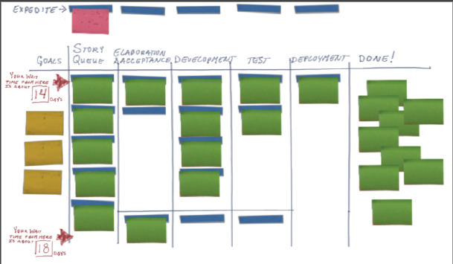
Done & Wait Queue

* In Case of usages of Tools like GreenHopper - Kanban Board are displayed electronically. In case no Tool is being used – Displaying Kanban board manually, can also be done.

Place prioritized goals on the left column of the board
A good goal describes the outcome we hope to achieve after software ships. Goals help keep focus on the larger outcome.
Having goals visible:
  - promotes focus
  - helps us prioritize
  - Helps us manage feature scope & requirements.

Decide on limits for items in queue and work in progress
A good limit is a factor of the number of people in a role that can work on an item in a given process step. A Thumb rule to begin with can be - number of people * 1.5

Start the board by placing stories or features in queue
Mark on the story or feature card the date it entered the queue. This begins our measurement of cycle time.
- Product owners manage the waiting queue

* Using a strict Kanban approach drops iteration planning from time-boxed iterations in favour of focusing on continuous flow.

Move features through the process flow as work is completed
As the story enters the first process step, mark that date on the card. This is the start date. As it’s finished, mark that date on the card. This is the finish date.

Use the dates on the cards to calculate cycle time
Use average cycle time to set wait times from different points on the board. Pay attention to flow and bottlenecks: relieving bottlenecks as quickly as possible.
- Cycle time = finish date – start date
The average cycle time from the date the item enters the board is the wait time from this point in the queue

Display and manage cycle times
- Reduce the number of Kanban slots allowed until cycle time remains unchanged
- Reduce the size of development items
  - Work in progress is actually the number if items * the average size of items
- Identify and act on bottlenecks immediately
  - Relieve repeated bottlenecks by changing the number and types of people in each role and cross training.

Additional kanban usage guidelines

Explode large process steps into tasks to improve visibility of flow
When a feature, user story, or work item is large:
    - Takes longer than a couple days to complete
    - Requires the multiple people collaborate on its completion
Decompose that step into cards to track independently

Use cumulative flow diagrams to visualize work in progress

An Example below :-
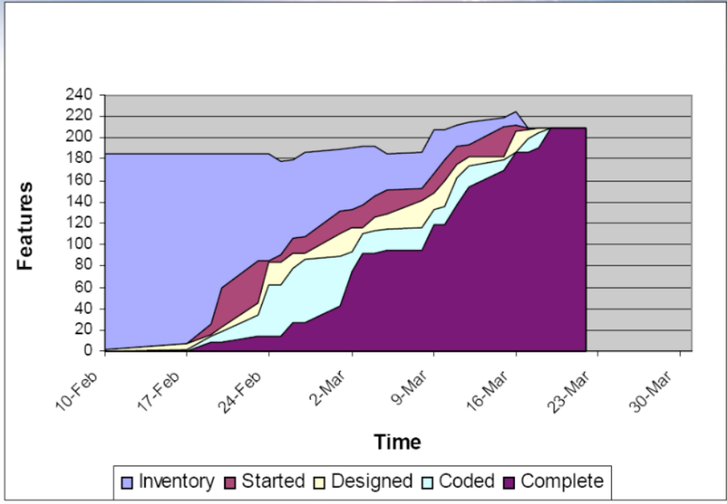

Keep regular time-boxes in your process as a cue for product inspection
Evaluate the quality of the growing product from a functional, engineering, and user experience perspective

Evaluate your pace of development:
- Look at the number of development items completed relative to goals
- Look at the average cycle time per development item
- Calculate the ratio of developer days per completed item. Use this ration to estimate the completion time for underdeveloped items
- Adjust your development plan as necessary

Evaluate and adjust the process you’re using
Use a process reflection session to identify changes you could make to improve your product or pace.

DOCUMENT HISTORY

Version | Date | Author | Reviewed by | Approved by | Nature of changes
1.0 | 19 Apr 2013 | Amit Ahuja/Satya, Saurabh Singh, Ashish Gupta | Shalini Joshi/Nidhi Saxena,QMG Agile Taskforce | Shalini Joshi/Nidhi Saxena | First Integrated issue
1.1 | 01 –Aug-2013 | Archana M | Senthilkumar S | Thenmozhi S | Ported template in new integrated template format post merger.

ANNEXURE
None.

